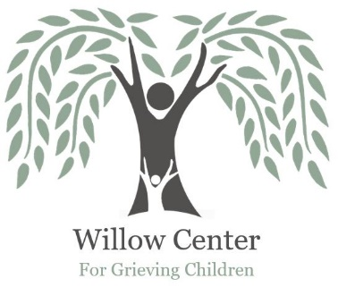
Willow Center
Volunteer Information

Contact Information
Name
Street Address
City, State, ZIP Code
Home/Cell Phone
Work Phone
E-Mail Address

Interests
Tell us in which areas you are interested in volunteering (make notes to the right as applicable).
Fundraising includes the following (can mark specific interests):
____ Event Assistance
____ Procurement of donations
___ Grief Program assistance, including attending events with children and families who are grieving
PR assistance volunteering at booths
___Camp Erin Volunteer
___ Other: _________________________________________________________________________

Previous Volunteer Experience

Interest in the Willow Center
Please briefly describe the reason you are interested in the Willow Center.

Person to Notify in Case of Emergency
Name
Street Address
City ST ZIP Code
Home Phone
Work Phone
E-Mail Address

Agreement and Signature
By submitting this application, I affirm that the facts set forth in it are true and complete. I understand that if I am accepted as a volunteer/board member, any false statements, omissions, or other misrepresentations made by me on this application may result in my immediate dismissal.
Name (printed)
Signature
Date

Our Policy
It is the policy of this organization to provide equal opportunities without regard to race, color, religion, national origin, gender, sexual preference, age, or disability.

Thank you for completing this application form and for your interest in volunteering with us.

Please return your completed application either via email to stephanie@willow-center.org

or mail to:

Willow Center

P.O. Box 1361

Lewiston, ID 83501

If you have questions, you may contact the Willow Center at (208)791-7192.

