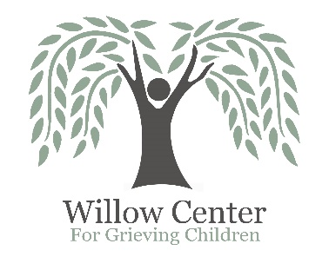**Willow Center**

**Volunteer Information**

|  |  |
| --- | --- |
| Contact Information – Please make a note of your preferred method of communication (e-mail, call or text) | |
|  | |
| **Name** |  |
| **Home/Cell Phone** |  |
| **E-Mail Address** |  |

|  |  |
| --- | --- |
| Interests | |
| Tell us in which areas you are interested in volunteering (make notes to the right as applicable). | |
|  | |
| Fundraising includes the following (can mark specific interests): | |
| ____ Event Assistance | |
| ____ Procurement of donations | |
| ___ Grief Program Facilitation (facilitating twice monthly peer group support groups) | |
| Office Assistance | |
| ___ Camp Erin Volunteer (summer weekend grief camp for kids) | |
| ___ Other: _________________________________________________________________________ | |
| Previous Experience – Please include any relevant experience including work, home or volunteer |
|  |
|  |
| Interest in the Willow Center |
| Please briefly describe the reason you are interested in the Willow Center. |
| Many of our volunteers choose to do so because they have experienced the death of a significant person in their life. Have you experienced the death of a significant person? Please explain: |
|  |
|  |
| Our Policy | | |
| It is the policy of this organization to provide equal opportunities without regard to race, color, religion, national origin, gender, sexual preference, age, or disability.  Thank you for completing this application form and for your interest in volunteering with us. | | |

## Please return your completed application either via email to casemanager@willow-center.org

## or mail to:

## Willow Center

## 1714 G Street

## Lewiston, ID 83501

## If you have questions, you may contact the Willow Center at (208)791-7192.